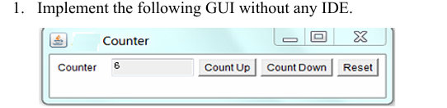

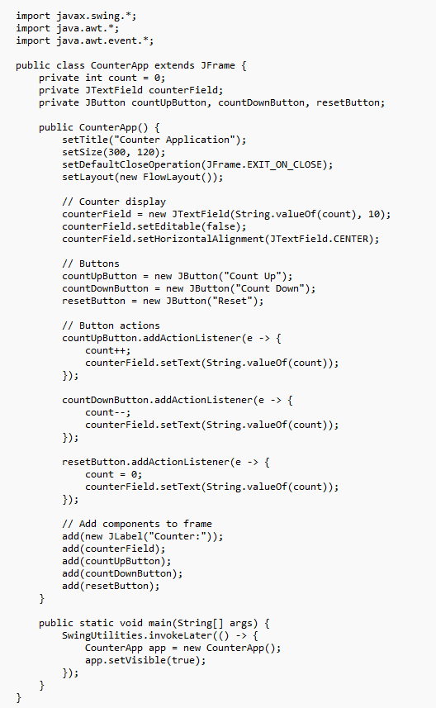

2. Write a GUI program to find the reverse of a given number using Swing (with IDE).

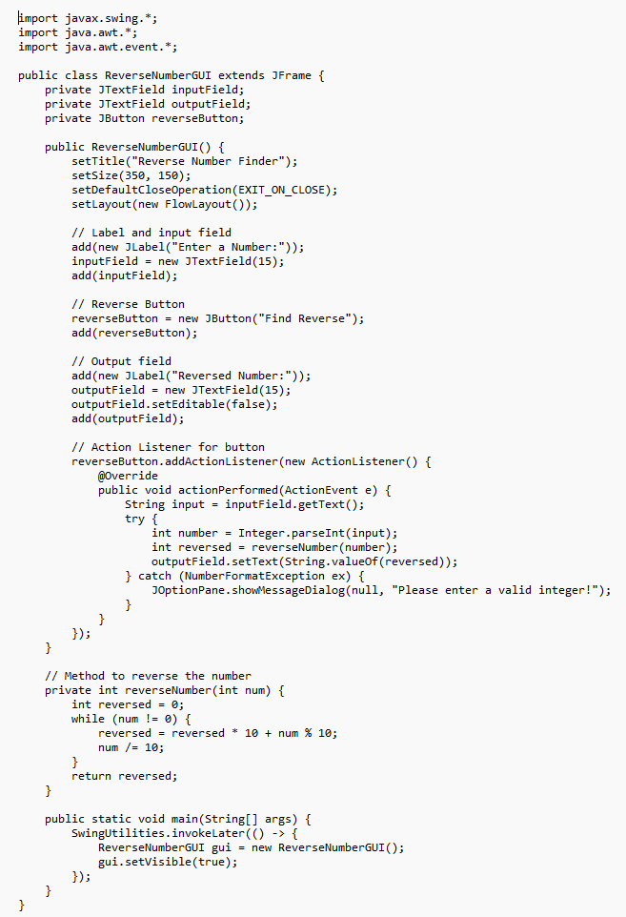

3. Write a GUI program to demonstrate the use of radio buttons (e.g., gender selection).

